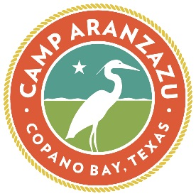
Camp Aranza-Crew Inquiry Form
This camp experience is a weekend of fun for families that include a child or young adult with special needs. You will get to enjoy our traditional and inclusive camp activities such as fishing, campfire, archery, and arts and crafts, while adhering to health protocols and staying safe at our fully accessible facility! $150 per adult; $100 per child ages 4 – 17. Includes meals, activities and lodging.

Family Name(s): ________________________________________________________________
Parent/Guardian First Name, Last Name:____________________________________________
Primary Phone Number(s): _______________________________________________________
Email Address: _________________________________________________________________
Preferred method of contact? _____________________________________________________
What camp dates are you interested in? ____________________________________________
Number of Family Members Attending the weekend: _________________________________
How did you hear about Camp Aranza-Crew? ________________________________________
Have you or a family member ever attended a camp at Camp Aranzazu before? If so, what camp and when? _______________________________________________________________

Please give a brief description of any pertinent information Camp Aranzazu should know about your family or your desire for this experience as we process these inquiries?
______________________________________________________________________________
______________________________________________________________________________

Parent / Guardian Electronic Signature _____________________________________________
Date _________________________________________________________________________

