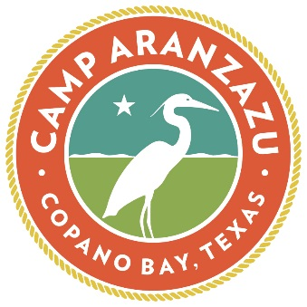
March 10, 2022
FOR IMMEDIATE RELEASE

Welcome back to Camp Aranzazu for the
13th Annual ZaZu BBQ, Music & More!
Spend an evening at Camp Aranzazu supporting
children and adults with special needs and chronic illnesses.

Rockport, Texas---The 13th annual “ZaZu BBQ, Music & More” will feature an icon of Lone Star music, Gary P. Nunn, and be held on Saturday, May 7, 2022, at Camp Aranzazu. All proceeds support Camp Aranzazu’s mission to enrich the lives of children and adults with special needs and chronic illnesses throughout Texas.
The evening will include a Coastal Bend-famous BBQ dinner cooked by the Corpus Christi Mustangs, a brief program, and a live auction. Guests can tour the Camp’s idyllic setting on Copano Bay and enjoy time with friends and family.
Following 2020’s live streamed ZaZu, our team is excited to welcome Coastal Bend supporters back to Camp Aranzazu for another evening of great food, strong drinks generously donated by L&F Distributors, and Texas country music - all in hope of making camp possible for the nearly 1,500 very special children and adults we plan to serve this year.
“Annie and I are thrilled to help chair this event, along with Reagan and Mary Margaret Sahadi, as it continues to grow in popularity in the Coastal Bend and welcome ZaZu guests back to Camp Aranzazu,” says Casey Cullen, Camp Aranzazu board member and ZaZu co-chair. “ZaZu is the perfect excuse to get out of the house, grab a group of friends and spend a Saturday evening supporting the camp. Not to mention, the great Gary P. Nunn will be providing the entertainment.”
“Our team is excited to once again be able to host 300 guests at this year’s ZaZu BBQ, Music & More at Camp,” says Kurt R. Podeszwa, Camp Aranzazu president. “After hosting the last ZaZu virtually in 2020, this year’s ZaZu will be the first time our guests have been able to visit since before the pandemic in 2019.”
“As we prepare for our busiest season at Camp Aranzazu, we hope to raise $150,000 which will help us underwrite a week at camp for 200 children and adults with special needs and chronic illnesses,” adds Podeszwa. “ZaZu provides a unique opportunity for our staff to show off our beautiful facilities and raise funds for our Coastal Bend area campers who will make up close to 50% of the population we plan to serve this year.”
Event registration is available at www.camparanzazu.org/events/zazu-2022. Tables range from $1,000 to $15,000. Tickets for the evening are $150 per person.
Camp Aranzazu is a 105-acre, barrier-free camp in Rockport, Texas. The camp’s mission is to enrich the lives of children and adults with chronic illnesses and special needs by providing unique camping, environmental education and retreat experiences. Since 2006, almost 27,500 children and adults have benefitted from the moments of joy, laughter, and independence they’ve found at Camp Aranzazu.

CONTACT INFORMATION
Kate Plouvier
Camp Aranzazu Development Director
281-667-6881
kate@camparanzazu.org

Follow us on Facebook https://www.facebook.com/camparanzazu/
Follow us on Instagram https://www.instagram.com/camparanzazu/

